

Request for Proposal
Yuba Community College District

Yuba College, Marysville Campus
Architectural-Engineering Services
Electrical Distribution Systems, Phase I
No. RFP 24-02

Issue Date: November 19, 2024
RFP Due: January 14, 2025

RFP Due Date: January 14, 2025, 1:00 PM Sharp, Yuba College Location Delivered To:

Yuba Community College District, District Offices
Attn.: David Willis
District Director of Facilities Planning, Maintenance & Operations
RFP No. 24-02 Yuba College, Electrical Distribution Systems, Phase I Upgrades, Architectural-Engineering Services
Address: Sutter County Campus, Second Floor, District Offices, Attention: David Willis, 3301 East Onstott Road, Yuba City, California 95991

Proposal Delivery at Second Floor
Yuba Community College District
Sutter County Campus
District Offices
3301 East Onstott Road (second floor)
Yuba City, California, 95991

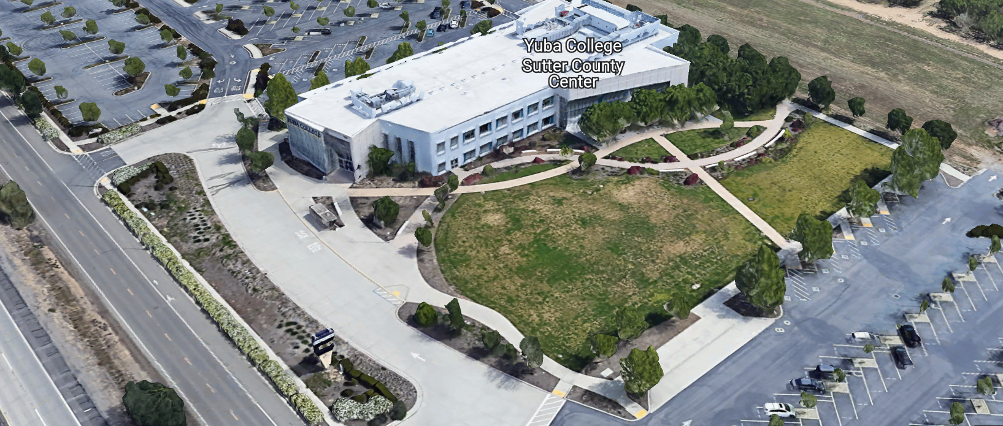
West Building Entrance
TABLE OF CONTENTS

1.0 INTRODUCTION
1.1 District Information
1.2 Yuba Community College District Background
1.3 Purpose of the Request
1.4 Applicable Codes
2.0 Scope of Work
2.1 Project Schedule
2.2 District Staff Contacts during Proposal Process
3.0 Proposal Format Organization
3.1 Proposal Delivery, Contents, and Format
4.0 Selection of “Firm”
5.0 Basis of Award
6.0 Non-Discrimination
7.0 Response to Request for Proposal (RFP)
8.0 Requests for Information (RFI)
9.0 Proposal Schedule
10.0 Evaluation of Proposals Form
11.0 District Parking
12.0 RFP Proposals
13.0 Award of Contract/Proposal
14.0 Reservation of Rights
15.0 Bid Bond Requirements (not applicable)
16.0 Performance Bond, Payment Bond Requirements (not applicable)
17.0 Liquidated Damages (Apply to late completion of the Construction Documents Package and Submission to DSA)
18.0 Protest Procedure

Proposal Required Items:

Appendix A, Proposal Bid Form
Appendix B, Statement of Qualifications
Appendix C, Acknowledgement of Addenda Form
Appendix D, Non-Collusion Affidavit Form
Appendix E, YCCD Professional Services Agreement, PSA (Can be provided by Successful Firm, not required on proposal due date)
Appendix F, Signature Proposal Form
Appendix G, Architectural Firm References (At least 10 Recent Up to Date References Required)
Appendix H, Preliminary Schedule, List of first tier Sub-Design Firms and Cost Estimating Firms, Architectural License, Engineering Licenses, other credentials.

Informational Items:
Appendix I: YCCD Academic Calendars
Appendix J: Map of Yuba College Campus
Appendix K: Background Project Information

1. INTRODUCTION

  - District Information:

The District consists of two colleges, Woodland Community College and Yuba College, with campuses located at six different locations: Yuba College in Marysville, CA; Sutter County Campus in Yuba City, CA; Woodland Community College in Woodland, CA; Colusa County Center in Williams, CA; and Lake County Campus in Clearlake, CA.

  - Yuba Community College District

The Yuba Community College District (YCCD) was founded in 1927 and spans eight counties (Yuba, Sutter, Colusa, Yolo, Lake, Butte, Glenn and Placer) and nearly 4,200 square miles of territory in rural, north-central California. It has colleges in Marysville and Woodland, a College campus in Clearlake, an educational center in Williams, and a College campus in Yuba City.

  - Purpose of Request

The Yuba Community College District seeks Proposals and Statements of Qualification from Licensed Architectural Firms to provide design services, DSA submission, and contract administration through construction.
Yuba College, Marysville Campus: 2088 North Beale Road, Marysville, Ca., 95901.

  - Applicable Codes
All work shall meet all State of California Building Codes, and Federal codes, and local ordinances.
All projects at the District/College are prevailing wage projects.
- Scope of Work

The Yuba Community College District is accepting proposals for “RFP 24-02, Yuba College, Electrical Distribution System, Phase I, Architectural Services”.

The project budget for the Electrical Distribution System, Phase I is approximately $3,500,000. This includes the soft and hard costs.

The Engineering Enterprise (TEE) (Danny McKevitt) has completed a Yuba College Campus-wide electrical distribution systems assessment/inventory and has generated an Equipment and Conductor/Wiring Risk Matrix that has prioritized what should be considered to be upgraded in the Phase I scope of work.

The Architectural Firm will need to include a cost estimate by a local Certified and Qualified Cost Estimating Firm of each of the items on the Risk Matrix Spreadsheets.

The Architectural Firm utilize exclusively “The Engineering Enterprise” (TEE) for all electrical engineering design services.

The Architectural Firm and The Engineering Enterprise shall review the cost estimates and make a recommendation to the District regarding which equipment and conductors (wiring) shall be included in the Phase I scope of work.

The Architectural Firm and The Engineering Enterprise shall generate a complete set of Construction Documents and Specifications.

The Architectural Firm and TEE shall submit the CD’s to the Division of the State Architect (DSA) for review and approval and support the DSA review and approval process. The District will pay all DSA fees.

The Architectural Firm shall provide contract administration services through the construction phase of the project to 100% completion.

The Architectural Firm shall provide the District with (6) DSA approved half-size drawing sets and (6) sets of specifications.

The Architectural Firm and TEE shall participate in the review of Contractor proposals to verify that they have all of the required scope of work included in the proposals and also to participate in the District’s Contractor prequalification and reference check process.

The Architectural Firm (TEE) shall generate ASI’s and RFI responses, and Construction Change Directives for DSA as required during the construction.

The Architectural Firm (TEE) shall review and approve submittals, change orders, and progress payments.

The Architectural Firm (TEE) shall also support the project close-out process by providing updated digital red-lined drawings, RFI’s, ASI’s, Submittals, etc.…

The Architectural Firm (TEE) shall also be on site when significant electrical distribution systems equipment is energized for the first time to ensure that the installation meets all design requirements prior to energizing the equipment.

The Architectural Firm (TEE) shall review the construction schedule of the contractor to ensure that it includes all critical items and to discuss the schedule with the Contractor and the District during regularly scheduled review meetings.

Preliminary Scheduled Meetings Plan:

Design Phase:

- On Campus Pre-Design Meeting (4 hours)
- On Campus Investigations of Existing Site Conditions (3 meetings x 4 hours each)
  - If additional meetings are needed at the College to ensure that all existing conditions are addressed, please include them in your proposal.
- 50% Design Review Meeting with the District (2 hours)
- 75% Design Review Meeting with the District (2 hours)
- 95% Design Review Meeting with the District (2 hours)

Phase I and II Cost Estimate Review Meetings:

- Three (3) cost estimate line by line review meetings (2 hours each meeting)

Contractor Bidding Meetings

Contractor Pre-Bid Meetings (2) (2 hours each meeting)
Proposals Evaluations Review Meeting with the District (2 hours)
(2) Interviews with the top (2) Contractors (2 total hours)

Construction Phase:

Weekly Owner/Architect/Contractor Project Team Meetings (30 to 60 minutes) Up to 70 meetings, up to 70 hours. These meetings may be scheduled on an as needed basis prior to and around the phases of construction.

Schedule Review Meetings with Contractor and District:

Monthly Schedule Review Meetings with Contractor and District: (18 meetings, 30 to 60 minutes, up to 18 hours total).

Construction Close-Out:

Up to 4 (1) hour meetings

Misc. Other Meetings: 6 other meetings up to 1 hour in length.

2.1 Preliminary Project Schedule
Approximate Award Date: February 28, 2025
Preliminary / Design Development Completed: April 18, 2025
50% Construction Documents Review: June 23, 2025
75% Construction Documents Review: July 21, 2025
95% Construction Documents Review: August 18, 2025
Drawings and Specifications Completed, Submission to DSA Date: September 15, 2025
DSA review completed: February 15, 2026
Project Bids Due: April 17, 2026
Award Contractor: May 29, 2026
Note: These are target dates which can be changed by the Architectural Firm to provide a preliminary schedule for this RFP. The District/College would like to make the needed changes as soon as is reasonably possible while also coordinating with the College to minimize any impacts to the operations and instructional mission of the College. The draft schedule will need to be provided with the proposal and will be subject to review and approval by the District/College.
Provide a project schedule with the proposal.
2.2 District Staff Contacts during the Proposal process:
Firms interested in submitting a Proposal are directed not to make personal contact with the Board of Trustees, District staff, or members of the evaluation committee. Any contact shall constitute grounds for disqualification from consideration.
Single Point of Contact during the Proposal Preparation Process:
David L. Willis
District Director of Maintenance, Operations, and Planning
Sutter Center, YCCD District Offices, room 217
3301 East Onstott Road
Yuba City, California, 95991
Cell Phone: 916-747-4262
Email: dwillis@yccd.edu

3.0 Proposal Format Organization
The Firm is requested to use the following proposal format:
3.1. Proposal Delivery, Contents, and Format:
Proposals should provide straightforward, concise information that satisfies the requirements noted in this RFP. Expensive binding, color displays, and the like are discouraged. Emphasis should be placed on brevity, conformity to the Districts instructions, selection criteria of this RFP, and completeness and clarity of content. Each Respondent’s proposal should clearly and accurately demonstrate specialized knowledge and experience required for consideration.
In a sealed box or envelope (clearly marked “), submit the following:
- One (1) flash memory stick containing the complete proposal and supporting documentation;
- One (1) original signed hard copy in paper form of the proposal, which consists of a Proposal Letter and responses to the proposal requirements of this RFP.

There is no page limit.

Firms must comply with the provisions of these instructions for completion and submission of the Proposal. The failure of a Firm to comply with the Proposal Instructions and Requirements will likely result (at the sole discretion of the District) in rejection of the Proposal for non-responsiveness.
Proposal Section | Format
- Cover Letter | PDF
- Table of Contents | PDF
Appendices (See Table of Contents for each one) Submit a response to each Appendix that requires Firm information. Please submit responses to Appendices A, B, C, D, E, F, G, and H. Appendices I, J, and K are informational only. | PDF

Proposal General Information Contents:

The information requested will help the District determine if the Firm is a “Responsible Proposer”.

Cover Letter

The Proposal shall include a Cover Letter on Respondent’s official business letterhead, which shall be signed by an individual authorized to legally bind Respondent. The Cover Letter shall also identify the name, telephone number, and email of a person who may be contacted during the Proposal evaluation process.

Table of Contents

Provide a Table of Contents that outlines in sequential order the major sections and sub-sections of the Proposal. Use tabs to allow information to be more easily located.

4.0 Selection of “Firm” Services Provider

The process of “Firm” selection is based upon the complete responsiveness of the RFP and the criteria as outlined in the RFP.

The District Project Evaluation Team will read the written proposals. The District Evaluation Team will discuss the proposals and verify that the “Basis of Award” information below, the Statement of Qualifications, and information submitted in response to the RFP are complete and responsive.

Process Summary:

- Evaluation of the Statement of Qualifications, and prequalification of Firms
(Note: If a Firm is not pre-qualified, their proposal will not be considered)
- Proposal Review
- Interview with Firm—if determined to be required by the District.
- References Check. Firms must have good references in meeting schedules, providing complete design packages that minimize change orders to less than 10%, and have positive references regarding services provided.
- Selection of most qualified, cost-effective comprehensive proposal which includes all needed and requested services as described in this RFP.

The District reserves the right to reject any or all proposals, to amend the RFP process, and to discontinue or re-open the process at any time. The District reserves the right to request clarifications to RFP responses and to negotiate the terms of the agreement. The District reserves the right to waive any minor issues, typo’s, etc., with the proposals.

5.0 Basis of Award

This project will be awarded based on the following criteria:

- Lowest Total Cost Responsive Qualified Proposer
  - Statement of Qualifications Evaluation, Interview, resulting in Prequalification.
  - Proposal Review, Complete and Comprehensive, and Lowest Total Cost.
  - Reference Checks

- Other Factors Considered in the above process:
  - Project Team, Credentials, Time Commitment
  - Proper State of California Architects License in good standing
  - Information provided as requested in the RFP.
  - All Addendums are acknowledged.
  - Architectural Firm’s exceptions or exclusions.
  - The Engineering Enterprise is listed as the Electrical Design Firm.
  - Architectural Firm with historical good performance on YCCD projects regarding minimal number and cost of change orders, maintaining project schedules and completing the work promptly, and overall quality of work.
  - Architectural Firm’s ability to meet the District’s schedule requirements.
  - Architectural Firm has demonstrated past project references of “like” projects
  - Architectural Firm’s references are all good with respect to schedule, cost, and quality.
  - Architectural Firm’s performance to provide complete Construction Documents for bidding that resulted in Contractor change orders under 10% consistently on all construction projects.
  - Architectural Firms thorough due diligence in doing on campus site investigations of existing conditions and including the District’s requests in the scope of work.
  - Architectural Firm’s inclusion of District standards regarding equipment brands and manufacturer’s exclusively, and not allowing “equals” in the project specifications.
  - No other factors such as litigation, licenses not in good standing, bankruptcy, or other similar criteria.

The one or two of the best qualified and lowest total cost responsive proposer’s may be requested to participate in a ZOOM interview process with the District Project Proposal Evaluation Team.

6.0 Non-Discrimination

The District does not discriminate with regard to race, color, gender, national origin, disability, or any other protected or other classification in the awarding of contracts/agreements. The District welcomes all Qualified Firms to participate in the project Request for Qualification/Proposal process.
The District encourages firms that are women or minority owned, emerging small businesses, veteran owned firms, disabled person owned firms, and all other qualified firms to participate in the proposal process.
The District encourages the submission of proposals from all Firms that can meet the stated requirements set for this RFP.
7.0 Responses to RFP:
Sealed responses to this RFP must be clearly marked "RFP No. 24-01 “ Yuba College, Electrical Distribution Systems, Phase I; Architectural-Engineering Services”.

Responses shall be mailed to or hand-delivered to the following address:

Yuba Community College District, District Offices
Attn.: David Willis
District Director of Facilities Planning, Maintenance & Operations

Envelope/Box Marked:
"RFP No. 24-01 “Yuba College, Electrical Distribution Systems, Phase I; Architectural -Engineering Services”.

Address: Sutter Center, District Offices, Second Floor, Room 217, Yuba City, California, 95991

Note: Completely seal your proposals in envelope/box and make sure it gets date/time stamped when delivering proposal. Firms are each 100% responsible to make sure proposals that are mailed using a carrier such as UPS, FED Ex, etc…are received and date/time stamped by District personnel prior to the proposal due date/time. No proposals will be considered if they are late, even if it is only 5 minutes late. Please make sure your proposals are delivered and received promptly prior to the due date/time. There will be a public proposal opening at the due date/time.

Do NOT email your proposals. Emailed proposals that are not sent per the above guidance requirements will not be considered.

8.0 Requests for Information (RFI)

Requests for Information concerning the RFP must be in writing and may be submitted via email no later than the date shown below. Please direct all questions to David Willis, email: dwillis@yccd.edu.

Following the RFI deadline, all questions and answers will be summarized and posted on the District's website: https://www.yccd.edu/central-services/purchasing/ , then, click on the “Requests for Proposals / Quotes” tab on the right hand side of this web page. It is anticipated that responses to inquires received by the required time and date will be provided within 5 business days and posted on the District website or responded to per the dates listed in the RFP for addendum publishing. Should more time be needed by the District to answer I respond to RFI’s, this information will also be posted on the above website.

- Include the following in the subject matter field on emails when requesting information: “RFP 24-02”, RFI.

9.0 Proposal Schedule:

Important Dates and Times:

November 19, 2025: Release of Request for Proposal at 1:00PM

December 3, 2004: 11:00 AM Optional ZOOM Pre-Bid Meeting:

Join Zoom Meeting
https://yccd-edu.zoom.us/j/82933987893

Cell Phone:
• +1 669 444 9171 US

December 11, 2024: 10:00AM to 12:PM (Noon) Optional On-Campus Pre-Bid Meeting in Building 1400, Maintenance Conference Room, then tour campus. Yuba College, 2088 North Beale Road, Marysville, Ca., 95901.

There are no mandatory pre-bid meetings.

January 6, 2025: 5:00 PM, All questions and requests for information must be submitted to David Willis at: dwillis@yccd.edu.

January 7, 2025: 5:00 PM, Addendum Issued if needed.

January 14, 2025: Proposals due at 1:00 PM SHARP, Yuba Community College District, District Offices Location: Sutter Center, District Offices, Second Floor, Room 217, Attention: David Willis, 3301 East Onstott Road, Yuba City, Ca., 95991. There will be a public bid opening on this RFP in room 211 at the Sutter Center Building.

10.0 Evaluation of Proposals Form

Firm: .

Proposals of Qualified Firms will be evaluated by a District Facilities Management Team, based on a number of factors which are described below:

Evaluation Criteria:

- Firm/Project Team Qualifications, Roles, Experience, Project Examples,
Time Commitment, DSA Experience, References: 40 Points

- Fee Proposal: 40 Points
- Previous successful work for the District 10 Points
- “Other Factors” Described in the RFP: 10 Points
.
.
Total Score: /100 Points

Comments:

Evaluator Name (Print): . Evaluator Signature: .
Date: . Recommendation to Interview: Yes/No: .

The Top 1 to 3 Best Qualified Firms with the Most Advantageous Proposal for the District will be interviewed. The interview will have a 50-point value with questions developed after reviewing the proposals.

The District may negotiate terms with the most qualified Firm that provides the most advantageous proposal for the District. The lowest cost proposer may not be awarded the project, at the full discretion of the District.
The Top 1 or 2 Best Qualified Firms with the Most Advantageous Proposal for the District may be interviewed by the District, at the District’s discretion. The interview will have a 50-point value with questions developed after reviewing the proposals.

The District may negotiate terms with the most qualified Firm that provides the most advantageous proposal for the District. The lowest cost proposer may not be awarded the project, at the full discretion of the District.

11.0 District Parking:

-No parking in Reserved Spaces without a proper permit
-Permit Parking is enforced in all general lots between 6:00 am and 6:00 pm, Monday through Friday. All general lots require a properly displayed, valid permit during these times
-Daily Parking Permits is $2.00
-Permits are available for purchase at any of the permit machines located in the student parking lots
-All other parking regulations are enforced 24 hours a day, seven days a week. This includes designated staff spaces, handicap spaces, timed spaces, red zones, yellow zones, and areas not marked (no parking at any time)
-Once this project is awarded, temporary parking permits will be processed as requested by the successful firm for all employees associated with this project at no cost to the Firm for the duration of the project at each Campus location. These temporary permits must be displayed at all times on the dashboard of employee vehicles.

12.0 RFP Proposals

Proposals received after the deadline date and time will not be opened. Each responder shall submit one (1) signed original written paper copy, in separate binders. Provide one electronic format copy of the proposal using electronic media such as a flash drive. (No CD formatted Disks).

All materials submitted in response to the RFP shall be on 8-1/2"x11" paper, preferably in
Portrait orientation. All submitted materials must be bound in either a three-ring binder or spiral bound notebook. Content shall be tabbed and numbered per the items included in the Submittal Requirements. All Proposals will be reviewed and evaluated by a District Selection Committee. The District at its sole discretion may interview finalists or select a firm or firms to perform work based solely on the evaluation of the Proposal. There is no page limit.

All Firm Proposals become the sole property of the District and the content will be held as confidential.

13.0 Award of Contract

- The Contract will be awarded to the lowest total cost, most responsive responsible District prequalified Architectural Firm, whose proposal, conforming to the request for proposal and associated addendums, will be most advantageous to the District.

B. The District reserves the right to enter into an Agreement without further discussion of the proposal submitted based on the initial offers received.

C. The District reserves the right to reject any or all proposals or any part of the proposal and to waive informalities and minor irregularities in the proposals received.

D. The RFP, its addendums, any follow-up clarifying information, and the proposal of the selected Firm will become part of any contract initiated by the District.

E. A formal contract shall be signed by the successful proposer and Yuba Community College District to perform this service.

F. The District reserves the right to enter into discussions with any one or all of the Responders after Proposals have been initially reviewed. Such responses shall be subject to all provisions, terms and conditions as set forth in the RFP, unless otherwise modified.

G. The District intends to award to a single RFP Responder.

H. BONDS: There are no bid bond, payment bond, or performance bond requirements on this Architectural Design Services RFP.

I. Failure to acknowledge all of the addendums, provide the items listed in the RFP, may render the proposal unresponsive at the discretion of the District. Items listed in the RFP become part of the contract unless the Architect provides an exception in the proposal. Architectural Firm exceptions, depending on the magnitude, may render the proposal unresponsive, at the discretion of the District.

J. The District reserves the right to request clarification of proposal content during the review and evaluation process.

K. The District reserves the right to negotiate the terms of the agreement to align with budgetary constraints.

L. The District reserves the right to not award to Firms that have not performed well by either meeting the District’s schedule requirements, not including the District’s standards or requests in the scope of work design, or if the District has experience with change orders greater than 10 percent on renovation and modernization projects, or if the District has experience with a Firm with greater than 4% in change orders on previous projects that are deemed to be Architectural Errors and Omissions.

M. The District reserves the sole right to determine which Firms are qualified and which Firms are not qualified based on information provided in the proposal in response to the RFP. The District’s evaluation information is confidential and not subject to public information requests.

14.0 Reservation of Rights

The District reserves the right to:

- Reject any or all submittals at its sole discretions.
- Cancel the Request for Proposal (RFP), without cause.
- Modify any requirements contained within the RFP and request a revised submission from all Providers.
- Establish other evaluation criteria determined to be in the best interest of the District.
- Contract with any of the firms responding to the RFP based solely upon its judgment of the qualifications and capabilities of the firm.
- Clarify the content of any proposal to verify that the requirements of the RFP are included.
- Waive “minor” proposal inconsistencies that do not change the scope of work as outlined in the RFP.
- Disqualify a Firm after reviewing the proposal and finding concerning performance information in references, inadequate or incomplete proposal information which renders the proposal unresponsive, and historically poor project performance at the District/Colleges (as solely defined by the District).

This RFP does not commit the District to award or negotiate a contract. The District will not be responsible for any expenses incurred by any firm in preparing and submitting a proposal or response to this RFP or in completing any of the work specified.

15. Bid Bond Requirements (Not applicable)

16. Performance and Payment Bond Requirements (Not applicable
17. Liquidated Damages (Apply to Late Completion of the Construction Documents Package)
The construction documents which include the drawings and specifications must be 100% completed and submitted to DSA no later than October 15, 2025. Liquidated damages after this date will be $100/day up to November15, 2025. After November 15, 2025, Liquidated damages will be assessed at $200/day until the full and completed Construction Documents Package is submitted to DSA for review.
Liquidated damages will be assessed against the total awarded fee amount for the project, reducing the total awarded fee amount that the Firm can invoice and be paid.
The District reserves the right to extend the above liquidated damages dates if unexpected unforeseen conditions warrant an extension at the full discretion of the District.
18. Protest Procedure
All Firms that have submitted a proposal will be provided an informational notice (email) with examples of supportive evidence that supports the District’s determination of not being pre-qualified/or awarded the project regarding the “Request for Proposal”. This notice will be issued as soon as the District Evaluation Team has completed it’s assessments.
Firms that wish to protest the decision of the District regarding whether to prequalify / award the Firm must submit a written notice with supportive information to the District “Point of Contact” noted in the “Request for Proposal” within three (3) working days of the initial written notice from the District.
YCCD RFP Point of Contact: David L. Willis, email: dwillis@yccd.edu, District Director of Facilities Planning, Maintenance and Operations.
The District Point of Contact person identified in the “Request for Proposal” will then review the evidence submitted by the Firm with the District’s Vice Chancellor of Administrative Services. The District will respond to the protesting Firm in writing within three (3) business days regarding it’s review of the additionally submitted information and decision. The District’s decision regarding this matter is then final. The information regarding this review process is deemed confidential.
Appendix A: Proposal Base Bid Form:

No. | Description | Cost
1 | On Campus Site Conditions Investigation of Existing Conditions | $
2 | Preliminary Planning/Design Development | $
3 | Construction Documents | $
4 | DSA Submission and support, DSA Fees paid by District directly to DSA. | $
5 | Contract Administration through 100% Completion and Project Close-Out, including DSA close-out. | $
6 | Cost Estimate generated by a local qualified CERTIFIED cost estimating Firm in the Local Sacramento Area that uses actual recent costs of other similar projects to help generate a cost estimate for this project | $
7 | Reimbursable Expenses: Architect to Define/Explain  Note: No hotel or travel costs | $
8 | Other: | $
9 | Total Costs: | $

Provide hourly rates for each design professional title.
Provide schedule of values.
Prevailing wages for design services are exempted through DIR for Architectural Services.

List all First Tier Sub-Design and Cost Estimating Firms.

Please round off numbers to the nearest dollar.

A preliminary overall start to finish project schedule is required with the proposal.

Please list all District requirements to support the Design process.

Note: The District does not have accurate existing conditions as-built drawings. The District will share what is existing. The Architectural Firm may need to scan existing hard copy drawings that are in archives at building 1400. All scanning costs are to be included in this proposal.

This project is being delivered as a traditional design, bid, build format. This is not a design-build project.

The District has a Net 30 day invoice payment policy.

It is the responsibility of the Architect-Design Firm Team to plan and submit it’s progress payments during the entire project schedule from start to finish to cover it’s expenses and to align with the overall project needs for support. Progress payment invoices are due monthly, the first week of each month for the previous month. Please use a standard Architectural Form such as the AIA G702 form when submitting progress payments.

Add Services change orders will not be considered unless the scope of the project changes and the District agrees with the reasoning of the Add Services request.

Appendix B: Statement of Qualifications (Important)
The Firm shall furnish the following information. Failure to comply with this requirement will render the submittal informal and may cause its rejection. Additional sheets may be attached if necessary.
Basic Firm Informational Items 1 through 16:

- Firm Name:___________________________________________________________________

- Primary Address: ______________________________________________________________

- Firm’s Contact Person and Title:___________________________________________________

- Telephone: ___________ Facsimile: ____________________

- Email Address: ___________________

- License No.: ______________________________ Class: __________________________

Responsible Managing Employee/Officer:___________________________________________

- Names and titles of two officers of the Firm:

NAME TITLE

8. Specific type of Ownership (Check one)

Individual
Partnership
Corporation; If a corporation, state the following:

State of incorporation:
Date of incorporation: President/CEO:
Joint Venture
Other (Specify)

- Taxpayer Identification No.: _______________________

- List annual gross income for last three (3) years:
Year: _______________ $_____________________
Year: _______________ $_____________________
Year: _______________ $_____________________

- Number of years Firm has been in business:
If less than 5 years, please describe:

- Number of years Firm has conducted business under the present name:__________
- Has the Firm ever been licensed under a different name or different license number? . If Yes, give name(s) and license number(s) and dates or operation under that name(s) and license number(s) (attach separate sheets if necessary):___________________________________________ _________________________________________________________ _________________________________________________________
- Number of years’ experience in California Community College, University or educational facility projects .

- Do you now or have you ever had any direct or indirect business, financial or other connection with any official, employee or consultant of the District? ___. If Yes, please elaborate:
_________________________________________________________

- Has the Firm ever completed any work at the Yuba Community College District? If Yes, please elaborate:

Potentially Disqualifying Questions 17 through 23 Firm’s refusal to answer or omission of response to any of Questions 17 through 23 may result in disqualification of Firm.:

- Does the Firm possess a valid and currently in good standing California Architects’ license? If Yes provide the license number(s). Yes/No______________________________________________________

- Has the Firm been defaulted or terminated (other than for convenience) by any California school district, community college district or other California public agency on any project within the past 5 years? Yes/No

If yes, identify agency and details:

- Has the Firm or any of its owners, officers, or partners, ever been convicted of a crime, or found guilty in a criminal action, involving fraud, theft, making any false claim or material representation to a public agency, or involving any federal, state, or local law, rule, or regulation related to Architectural Services or Construction? Yes/No_____

If yes, explain, identify the agency, and provide case name and number.

- Has the Firm been assessed liquidated damages for any project in the past five years? Yes/No If so, identify owner and details:

- Has the Firm ever failed to complete a project in the past five years? Yes/No: If so, give owner and details:

- Is the Firm currently or has the Firm been in a state of “Bankruptcy” in the past five years? Yes/No:
If yes, please explain.

- Please describe the Firm’s commitment to maintaining a construction schedule. How will the Firm recover the schedule if it slips due to weather or COVID-19 or similar illness impacts, or the Firm gets busy with other projects? Please describe specific actions the Firm will take to maintain the Project schedule.

Scoring/Rating Questions:

- Please list and describe on separate sheets the Firm’s top 10 “like” Electrical Distributions System Project at a K-16 entity in California. The project reference list should include the following criteria:
  - Project Name
  - Project Owner and Contact Information
  - Project Scope
  - Division of the State Architect (DSA) Experience: Yes/No
  - Original Contract Completion Date
  - Actual Project Completion Date
  - Original Construction Contract Price
  - Final Adjusted Construction Contract Price or Change Orders Total Cost
  - Any issues that Firm had to overcome on the project

Scoring Criteria:
  - “Like” type Projects (30 points)
  - DSA Experience (20 points)
  - Project Change Orders less than 5% (up to 20 points)
  - Have worked with The Engineering Enterprise on other projects (up to 20 points)

Total points: up to 90 points

- How many years has your Firm been in business in California as an Architectural Firm under your present business name and license number? __________
(less than 5 years = 0 points; 5-7 years = 5 points; 8+ years = 10 points.)

- In the last 10 years, how many legal proceedings (filed in court or arbitrations) has your Firm initiated against an owner, regardless of outcome? _______
(0 = 10 points; 1 = 5 points; 2+ = 0 points.)

- In the last 10 years, how many legal proceedings (filed in court or arbitrations) has an owner initiated against your Firm, regardless of outcome? _______
(0 = 10 points; 1 = 5 points; 2+ = 0 points.)

- Has your Firm been denied an award of public works contract based on a public agency’s finding that your Firm was not a responsible Proposer within the last 10 years? ______
(No = 5 points; Yes = 0 points.)

- Please describe the Capability/Capacity of your Firm. Please provide a comprehensive list of projects that the Architectural Firm has in process and reasoning/justification regarding how the Firm has capacity to perform the required services on this project.

(Up to 20 points.)

- Please list and describe the Firms Team Members that will be working on the project, roles, percent of time commitment, and provide support information of their experience working on “like” projects and credentials. Has this team worked together before? Provide examples.

(Up to 40 points.)

Qualification Criteria:
Questions 1 through 16 are general base level information that is required for pre-qualification.
Questions 17 through 23 are possible disqualifying questions that would render the Firm “not qualified” as determined by the District.
Questions 24 through 30 are rating questions that are scored and more deeply evaluated. Not scoring the minimum threshold value will render the Firm “not qualified”.
  - There are a total of 185 points possible.
  - The District can disqualify a Firm (at it’s sole discretion) if the Firm does not meet the requirements of Questions 17 through 23.
  - Each Firm must score at least 150 points.
  - Step 1: Pre-qualification includes the following:
    - Statement of Qualifications Analysis and Total Score
  - Step 2: Once a Firm meets the 150 point threshold, the top 2 or 3 Firms will be interviewed if the District evaluation team determines the need. Interviews score 50 points. Interviews must score at least an average score of 35 out of 50 points.
  - Once Firms are Pre-Qualified, and Interviewed if the District so choses, Proposals will be evaluated.
  - All proposals must score at least 70 out of 100 points on the proposal score sheet in section 10.0 in this RFP as an average score of the District Evaluation Team to have the Firms proposal to be considered.
The undersigned is duly authorized to execute this Statement of Qualifications under penalty of perjury on behalf of the above-identified Firm. The undersigned warrants and represents that he/she has personal knowledge of each of the responses to this Statement of Qualifications and/or that he/she has conducted all necessary and appropriate inquiries to determine the truth, completeness, and accuracy of responses to this Statement of Qualifications. The undersigned declares and certifies that the responses to this Statement of Qualifications are complete and accurate; there are no omissions of material fact or information that render any response to be false or misleading and there are no misstatements of fact in any of the responses. The above-identified Firm acknowledges and agrees that if the District determines that any response herein is false or misleading or contains misstatements of fact so as to be false or misleading, the District may find the Firm is not qualified and the District can reject the proposal for non-responsiveness or non-responsibility.

Executed this___ day of __________________ 20__ at_____________________________.
(City and State)
I declare under penalty of perjury under California law that the foregoing is true and correct.

By: ____________________________________________
(Signature of Firm’s Authorized Officer or Representative)
____________________________________________
(Typed or Printed Name)
Title: ___________________________________________

Appendix C: Acknowledgement of Addenda Form

The undersigned acknowledges receipt of the following addenda from the District pursuant to the Request for Proposal:
Acknowledgement: Yes or Not Applicable
Addendum No. 1: .
Addendum No. 2: .
Addendum No. 3: .
Addendum No. 4: .
Addendum No. 5: .

Firms are required to acknowledge all addenda’s within the submitted proposal at the time of submission.

Appendix D: Non-Collusion Affidavit Form

STATE OF CALIFORNIA, COUNTY OF I, being first duly sworn, deposes and says that I am the of , the party submitting the foregoing proposal (“the Proposal”). In connection with the foregoing Proposal, the undersigned declares, states and certifies that:
- The Proposal is not made in the interest of, or on behalf of, any undisclosed person, partnership, company, association, organization or corporation.
- The Proposal is genuine and not collusive or a sham.
- The Firm has not directly or indirectly induced or solicited another Firm to put in a false or sham proposal, and has not directly or indirectly colluded, conspired, connived, or agreed with any other Firm or anyone else to put in a sham proposal, or to refrain from bidding.
- The Firm has not in any manner, directly or indirectly, sought by agreement, communication, or conference with anyone to fix the proposal price, or that of any other Firm, or to fix any overhead, profit or cost element of the proposal price or that of any other Firm, or to secure any advantage against the public body awarding the contract of anyone interested in the proposed contract.
- All statements contained in the Proposal and related documents are true.
- The Firm has not, directly or indirectly, submitted the proposal price or any breakdown thereof, or the contents there of, or divulged information or data relative thereto, or paid, and will not pay any fee to any person, corporation, partnership, company, association, organization, proposal depository, or to any member or agent thereof to effectuate a collusive or sham proposal.
Executed on this date: , 2025/2026, at:

(City, County, and State)
I declare under penalty of perjury under the laws of the State of California that the foregoing is true and correct.
Signature Printed Name .
Address: .
Area Code & Phone Number: .
Note: In addition to other bid documents, bidders on public works projects are required by Public Contract Code section 7106 to submit a certification form that they have not colluded with another proposer.

Appendix E: YCCD Professional Services Agreement
Link:
https://goyccd-my.sharepoint.com/:w:/g/personal/w0398409_yccd_edu/EYK1u58O465BkoWMVO7DKd0BxNNM5eHD-GIL_-rgKcwWPg?e=m9XoNM
This agreement is optional at the time of the proposal submission.
The successful Firm will be required to provide this agreement within 7 days after requested by the District.

Appendix “F” Proposal Signature Form
The undersigned acknowledges the following:
- Having become familiar with the specifications and requirements of the Request for Proposal, hereby offers to provide all services in accordance with the proposal set forth herein, including all referenced material and attachments.
- By submitting a signed proposal in response to this solicitation, the Firm acknowledges that they completely understand the scope of the needed services and that the proposed services as described in the proposal will meet or exceed the needs of the District.
- Late proposals will not be accepted (even if they are only 5 minutes late).
- The District reserves the right to reject any and all proposals and that this proposal shall remain open and not be withdrawn for a minimum of 90 days.
- Cancellation Clause: The District may, without cause, terminate the contract(s) or a project under the contract(s) by giving written notice of such termination to the awarded firm. In the event of such termination the District shall reimburse the firm for services performed and reasonable expenses actually incurred by the firm in relation to the terminated project prior to the firm’s receipt of such notice of termination. The cost of proposal generation, associated travel, copies, postage, etc.., will not be reimbursed and is considered a typical and normal part of the bid process and is not reimbursed for any of the proposers.
- If the prospective Firm is a corporation, the undersigned hereby represents and warrants that the corporation is duly incorporated and is in good standing in the state of California , and that, , is authorized to act for and bind the corporation.

Entity Type (Select One):

Sole Owner: Partnership: .

Corporation: .

Other; Please specify;

- Regular monthly progress payments are made using NET 30 as a basis for payment, with Net 30 time starting after receipt of the invoice with all required support documentation, and once this information is reviewed and approved by the District.

Invoices must be emailed to the following with all support documentation:
Heather Gardner: email: hgardner@yccd.edu ;
Rachel Harvey; email; rharvey@yccd.edu
It is critical that invoices have all required support documentation including an updated schedule of values with 5% retainage for construction projects, updated project schedule, description of completed work, and any other information that will help to justify and support the progress payment request.

Signature_____________________________ Date: _______________________
Position: _____________________________
Print name____________________________ Title________________________

Notary Required On This Project
Notary Stamp:

Appendix “G” References Form (Example Template)

Bidder shall provide a minimum of Ten (10) verifiable references with current contact information, preferably from a California public educational institution and/or California public agency, representing projects started and completed within the last 5 years. See clarification note below regarding reference requirements. This information can be provided as part of the Statement of Qualifications.
All phone numbers and emails must be current (please verify).
REFERENCE #1
NAME
ADDRESS
CITY, STATE ZIP CODE
TELEPHONE #
CONTACT
DATES OF SERVICE
REFERENCE #2
NAME
ADDRESS
CITY, STATE, ZIP CODE
TELEPHONE #
CONTACT
DATES OF SERVICE
REFERENCE #3
NAME
ADDRESS
CITY, STATE, ZIP CODE
TELEPHONE #
CONTACT
DATES OF SERVICE

You may of course use the Firm’s established reference template.

Appendix H: Preliminary Schedule, List of first tier Sub-Design Firms and Cost Estimating Firms, Architectural License, other credentials.

Appendix I: YCCD Academic Calendar

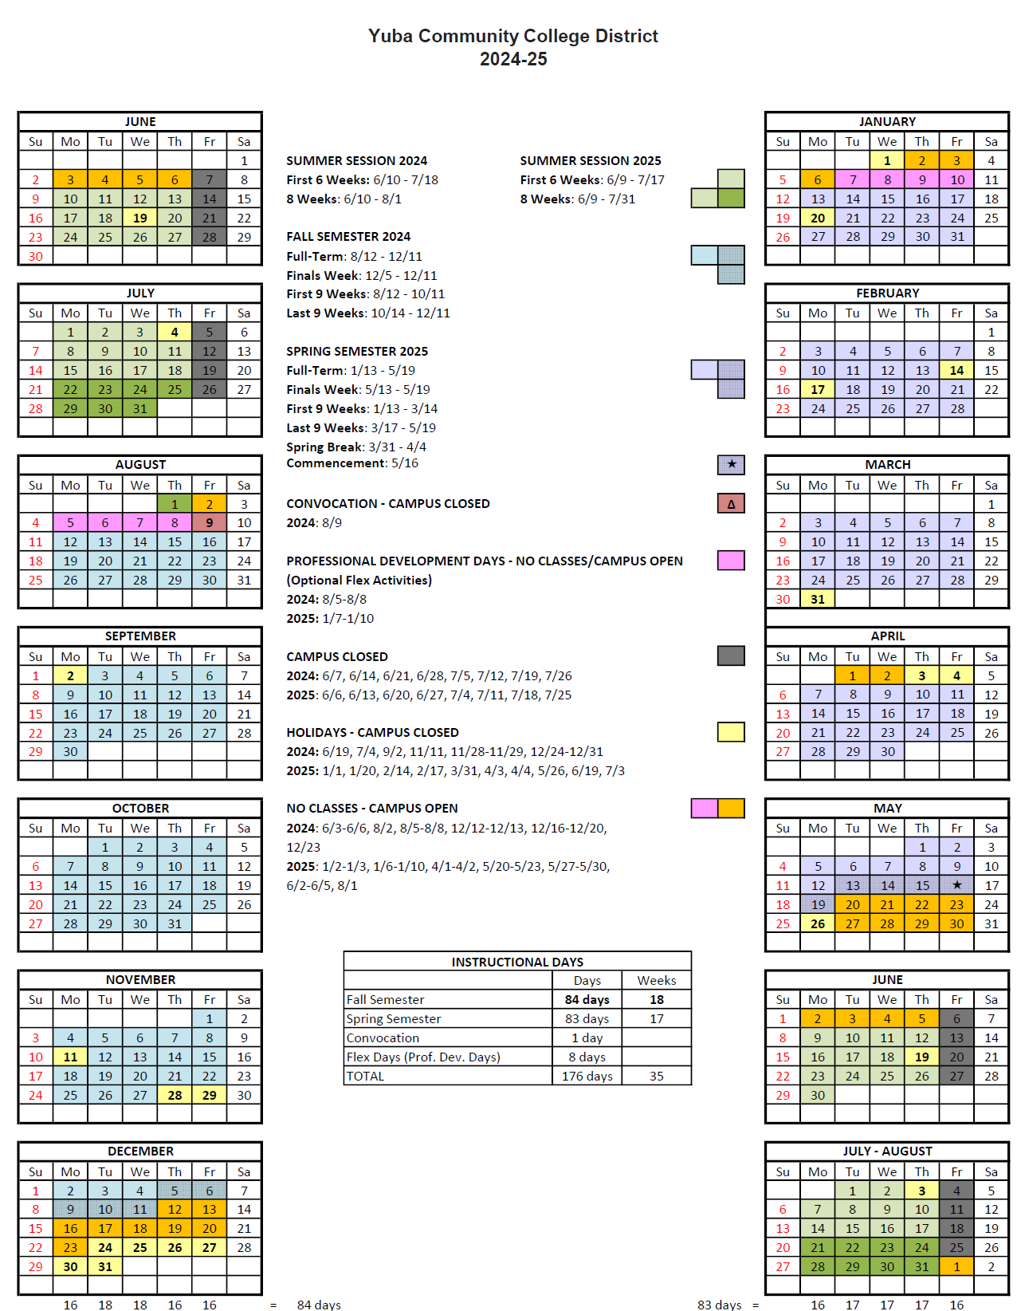

Appendix J: Map of Yuba College Campus
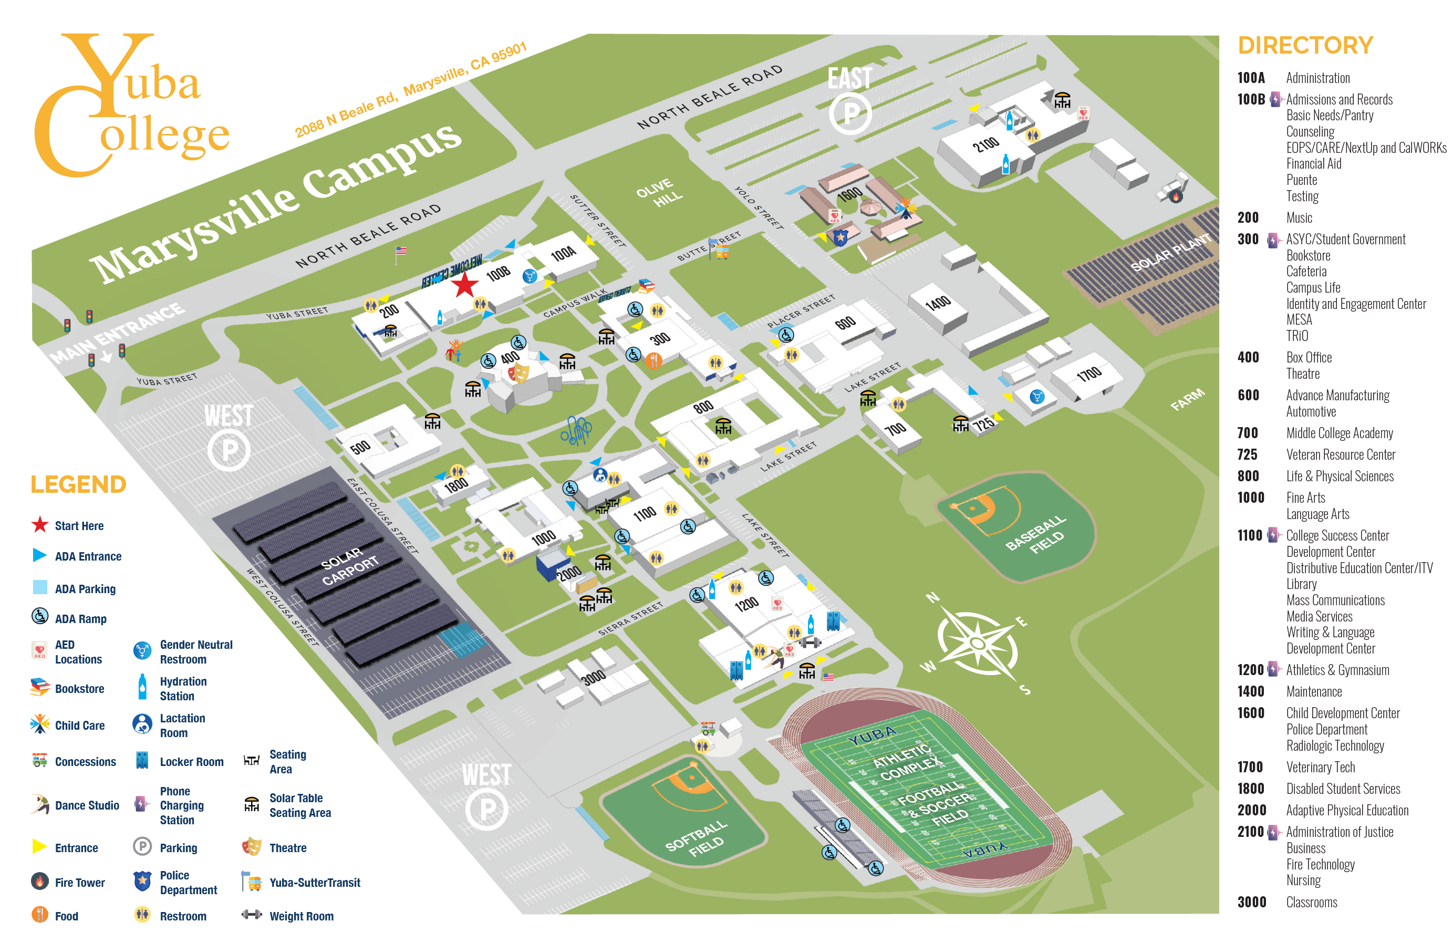

Appendix K: Background Project Information

Yuba College Electrical Distribution System Existing Drawings:
The Engineering Enterprise is currently generating an up to date electrical distribution system one-line diagram.
The District does not have accurate as-built drawings of the Yuba College electrical distribution systems.

Yuba College Electrical Distribution System Equipment Assessment/Inventory and Risk Matrix:
Link:
https://goyccd-my.sharepoint.com/:f:/g/personal/w0398409_yccd_edu/EnSY3J3zGj9LpEe_6by_W5EBcnqBE1qXzahyt-VBnL0urw?e=SgxlJ1

Yuba College Electrical Distribution System Recent Thermography and Repairs:
https://goyccd-my.sharepoint.com/:f:/g/personal/w0398409_yccd_edu/EoNmBpjkiuVLoTz4HUByjs4BZbZuFocVYiSIS0d-SVQe9g?e=wNxXBy

The End.

